***Team Name: Sunshine Boys***

***App Name: Sb Weather***

***File: User Experience***

**First Screen when you launch the app**

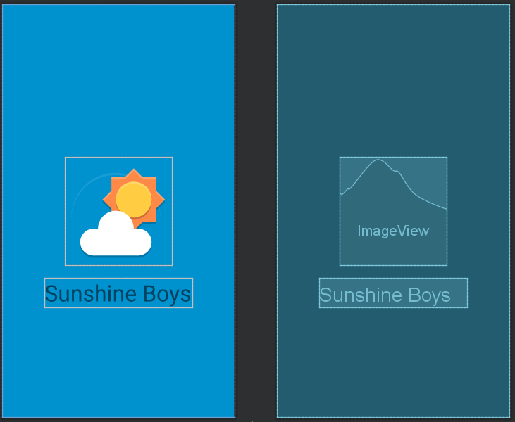

**Next screen after the splash screen(logo screen)**

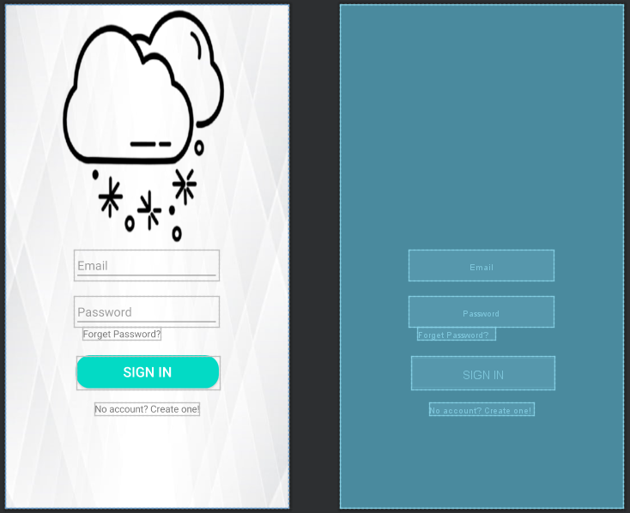

**Registration page, when “Already have an account? Sign in” is clicked.**

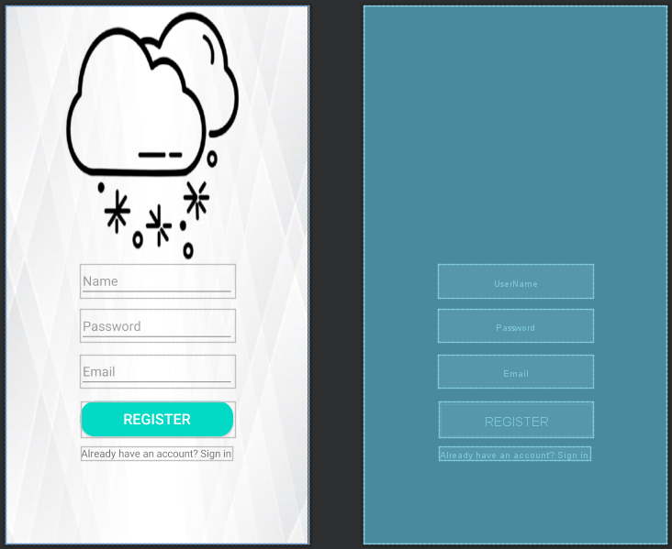

**Reset Password page, when “Forgot password?” is clicked.**

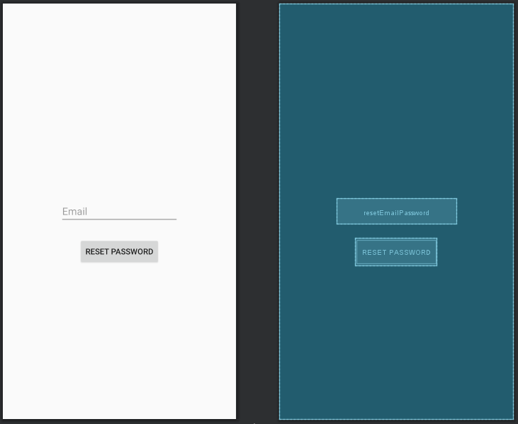

**Home Page, after the user credentials are verified through the database.**

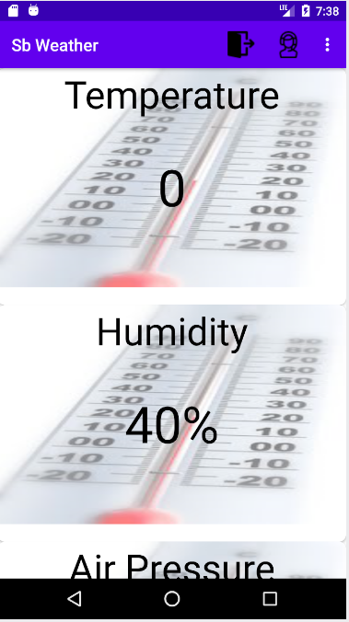

**RecycleView for home page, that ‘welcome’ textview needs to be removed**

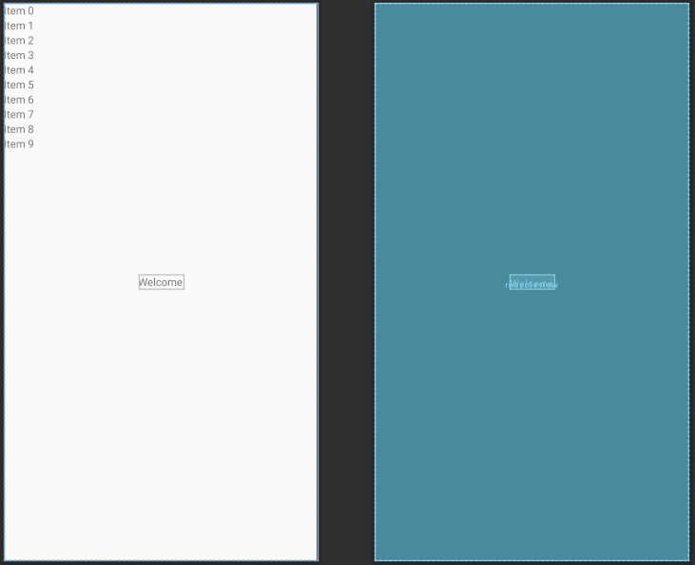

**CardView for home page, it uses this picture for all the items. We set only 1 picture for testing purposes.**

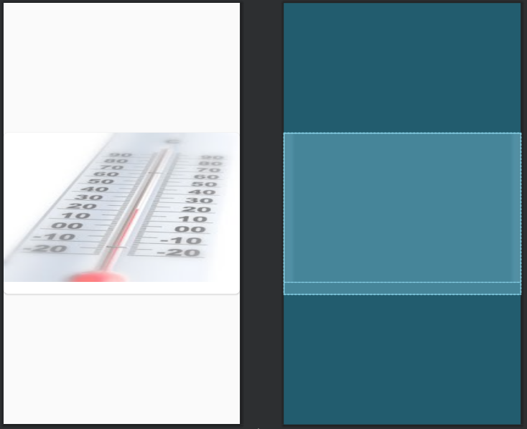

**Contact Us Page, which includes Humber’s phone number, our company email, GitHub link and this will also be our landscape screen**

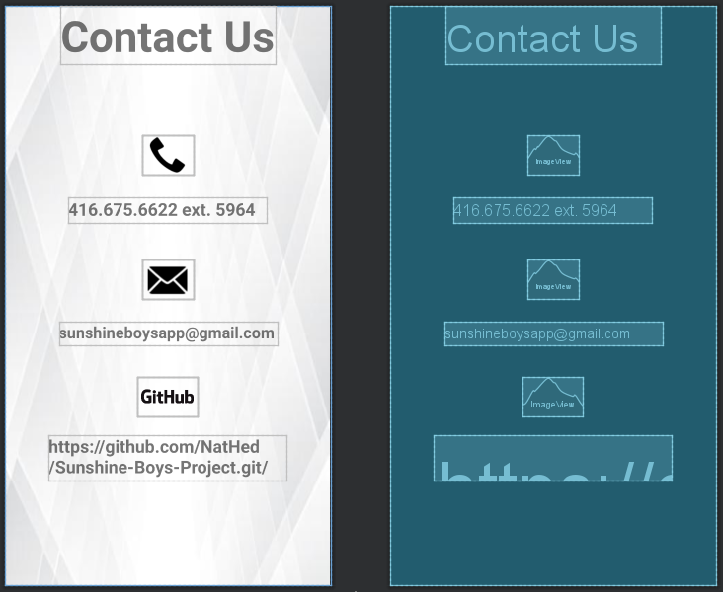

**About Us Page, some information about our company, this will also be our 2nd landscape screen**